# **E-VOTING SYSTEM BASED ON AUTHENTICATION USING GSM MODULE AND MICROCONTROLLER**

**A PROJECT REPORT**

**Submitted by**

P. VENKATA TEJA (212219060193)

P. CHARAN KUMAR (212219060196)

P. MARUTHI (212219060198)

***In partial fulfilment for the award of the degree***

***of***

**BACHELOR OF ENGINEERING**

***in***

**ELECTRONICS AND COMMUNICATION ENGINEERING**



# **SAVEETHA ENGINEERING COLLEGE (AUTONOMOUS) ANNA UNIVERSITY: CHENNAI - 602105**

# **APRIL 2023**

# **BONAFIDE CERTIFICATE**

Certified that this Report titled **“E-VOTING SYSTEM BASED ON AUTHENTICATION USING GSM MODULE AND MICROCONTROLLER”** is the bonafide work of “**P. VenkataTeja** **(212219060194)**, **P.Charan Kumar (212219060196)**, P.Maruthi (212219060198)” who carried out the work under my supervision.

**SIGNATURE SIGNATURE**

Dr. SRIGITHA S NATH, M.E., Ph.DDr. P. Vinayagam, M.E.,Ph.D

**HEAD OF THE DEPARTMENT SUPERVISOR**

ProfessorAssistant Professor (SG)

Department of ECE, Department of ECE,

Saveetha Engineering College, Saveetha Engineering College,

Thandalam, Thandalam,

Chennai - 602105Chennai – 602105

Submitted for the project viva-voce examination held on __________________.

**INTERNAL EXAMINER EXTERNAL EXAMINER**

**ACKNOWLEDGEMENT**

If words were considered as symbols of approval and token of acknowledgement, then let words play the heralding role of not praising and glorifying but also to exhibit the deeply embedded feelings of thanks and gratefulness.

We wish to express our gratitude to our Founder president, **Dr. N.M. Veeraiyan,** President **Dr. V. Saveetha** and Director **Dr. S. Rajesh** and for providing us with the facilities for the completion of our project. We also thank our principal **Dr.N.Duraipandian, M.E, Ph.D.**, for his continuous support and encouragement in carrying out our project work. Also, our thanks to **Dr. Srigitha S Nath M.E., Ph.D.,** Professor and Head of the Department, Electronics and Communication Engineering of our college for providing us facilities and permission to carry out our project work

We mention our special thanks to our project coordinator **Dr. Navaneethan S M.E.,** **Ph.D.,** Assistant Professor, Department of Electronics and Communication Engineering for his wisdom, guidance, and constant encouragement. We manifest a deep sense of gratitude to our internal guide **Dr. P.Vinayagam M.E, Ph.D.,** Assistant Professor and Head of the Department, Department of Electronics and Communication Engineering for her encouragement and faith in this endeavor.

We take this opportunity to acknowledge the efforts to staff members and friends at Saveetha Engineering College for their sincere cooperation in guiding us. Finally, we express our deepest gratitude to our family, for their constant encouragement, support and motivation throughout undergraduate career and for always being there for us.

**ABSTRACT**

An online voting system with PHP and XAMPP is a web-based application that allows users to cast their votes for elections or surveys over the internet. The system is designed to be secure, accurate, and user-friendly.

The main objective of the system is to automate the voting process and to make it more convenient for voters. The system includes a user registration process, voter authentication, and vote casting process.

The system also includes an administrator dashboard to manage the voting process and to generate reports. This abstract provides an overview of the design and functionality of an online voting system with PHP and XAMPP.

A secure online voting system with a user interface that is both simple and interactive is available. The proposed web portal is safe and includes advanced security features such as advanced id generation, which provides another layer of security (in addition to login id and password) and allows administrators to validate end user information and determine whether or not they are qualified to vote.

It also develops and handles voting and poll details, which are required by all end users. login by end user name and password and click on candidates to register vote

# 

# 

# **TABLE OF CONTENTS**

# **CHAPTER NO. TITLE PAGE NO.**

# **ABSTRACT** I

# **LIST OF FIGURES** V

# **LIST OF TABLES** VI

# **LIST OF SYMBOLS AND ABBREVIATION** VII

# **CHAPTER - 1**

1.1 INTRODUCTION 1

1.2 TOOLS USED 2

**CHAPTER - 2**

2.1 LITERATURE SURVEY 3

2.1.1 RELATED WORKS 4

2.2 EXISTING SYSTEM 6

2.2.1 DRAWBACKS 7

2.2.2 PROBLEM IDENTIFICATION 8

2.2.3 WORKING TABLE  **9**

**CHAPTER - 3**

3.1 PROPOSED METHODOLOGY  **10**

3.2 WORKFLOW 1**1**

3.3 SYSTEM SOFTWARE AND HARDWARE

3.3.1 - System software 1**3**

3.3.2 - hardware requirements 1**3**

3.4 XAMPP Control Panel 1**4**

3.5 Visual Studio Code 1**6**

3.6 Microcontrollers  **18**

3.7 GSM Module 1**9**

3.8 Web Server For User Access

3.9 Code Implementation

3.9.1 Admin Code in HTML 2**0**

3.9.2 Saving Vote in PHP 2**6**

**CHAPTER - 4**

4.1 Software System Design  **34**

**CHAPTER - 5**

5.1 Result 35

**CHAPTER - 6**

6.1 CONCLUSION 39

6.2 FUTURE SCOPE 39

**REFERENCES** 40

**LIST OF PUBLICATIONS** 42

**List of Figures**

**Fig.1** XAmpp Control Panel

**Fig.2** Visual Studio Code

**Fig.3** Microcontroller

**Fig.4** Implementation using VS Code

**Fig.5** Web Server Diagnosation

**Fig.6** Casting Vote Page

**Fig.7** User details to enter

**Fig.8** Results displayed after Elections

**List of Tables**

|  |  |
| --- | --- |
| **Sl. No.** | **Table Name** |
| 1 | Working Table and problem description |

**List Of Symbols And Abbreviations :**

IDE - integrated development environment

VSC - Visual Studio Code

HTML - Hypertext Markup Language

SQL -Structured query language

DBMS -database management system

OS - operating system

RAM -Random Access Memory

SSD - solid-state drive

CSS - Cascading Style Sheets

GSM - Global System for Mobile communication

**CHAPTER 1**

**1.1 INTRODUCTION**

In the current voting system , The first and the major disadvantage is that the casting of others votes by the particular person or a group of people ,Secondly the respective people who want to cast their votes don't cast due to the long queue in the poll booth. This second drawback is a major challenge for the government because the government takes many initiatives to get all the citizens to cast their vote but in every election they fail with their ideas.

With the help of our project both the problems of the current voting can be overcome as well as with the help of the block chain technology we have created a secure way of casting votes by the individual.

The internet has revolutionized many aspects of our lives, and the way we conduct elections and surveys is no exception. Online voting systems have gained popularity in recent years due to their convenience, accessibility, and accuracy. An online voting system with PHP and XAMPP is a web-based application that allows voters to cast their votes from any location using the internet. The system is designed to be user-friendly and secure, ensuring that the voting process is transparent and reliable. The use of online voting systems can bring numerous benefits to organisations and communities.

For example, online voting can increase voter turnout by making it easier and more convenient for people to participate. It can also save time and resources by eliminating the need for physical polling stations, which can be costly and time consuming to set up.

Additionally, online voting can provide faster and more accurate results, reducing the risk of errors or fraud. However, online voting systems also pose some challenges, such as ensuring security and privacy, preventing voter fraud, and ensuring accessibility for all voters, including those with disabilities. Therefore, the design and implementation of an online voting system must take these challenges into consideration to ensure a fair and reliable voting process. Overall, an online voting system with PHP and XAMPP can transform the way we conduct elections and surveys, making the process more accessible, convenient, and accurate. The system can bring numerous benefits to organizations and communities, but it must be designed and implemented with security and privacy in mind to ensure a fair and transparent voting process.

**1.2 TOOLS USED**

**HARDWARE REQUIREMENTS**

1. PERSONAL COMPUTER (WITH WINDOWS 10 INSTALLATION)
2. POWER SUPPLY UNIT
3. STORAGE IN PC

**SOFTWARE REQUIREMENTS**

1. XAMPP APPLICATION
2. VISUAL STUDIO CODE
3. WEB SERVER
4. OPERATING SYSTEM

**CHAPTER 2**

**2.1 LITERATURE SURVEY**

**Title - 1 :** Aadhar Card Verification Base Online Polling.

**Authors :** jithina jose

**Description :** An Efficient System to Predict and Analyze Stock Data using Hadoop techniques.

**Limitations :** Privacy and Verifiability

**Title - 2 :** A Minutiae-Based Fingerprint Matching Algorithm Using Phase Correlation.

**Authors :** Diwakar Agarwal

**Description :** Matching the fingerprint with aadhar based users.

**Limitations :** It also included the paper based voting

**Title - 3 :** Topological Voting Method for Image Segmentation.

**Authors :** Xiaohao Cai, Ping Zhong and Gaohang Yu.

**Description :** The mathematical guarantee and the experimental results

**Limitations :** Can’t develop the technique for the large scale elections.

**Title - 4 :** Automatic Voting System Using Convolutional Neural Network.

**Authors :** M S Sruthi and K Shanjai

**Description :** This Automatic Voting system would take the place of the time-consuming and difficult-to maintain manual process.

**Limitations :** Detecting Under Neural Network transportation of chain codes.

**Title - 5 :** Voting Machine Using Face Recognition

**Authors :** A Samundeeswari

**Description :** This machine detects faces to identify the person to cast their vote.

**Limitations :** Detection of facial image segmentation

**2.1.1 RELATED WORKS**

**Helios Voting** : Helios is an open-source online voting system that uses cryptographic techniques to ensure the privacy and integrity of votes. It is written in Python and uses a web-based interface. Helios is designed to support a variety of voting methods, including plurality, approval, and ranked-choice voting.

**Scytl Online Voting :** Scytl is a commercial online voting system that uses end-to-end encryption to ensure the integrity and confidentiality of votes. It is designed to support a variety of voting methods, including traditional paper-based voting, remote voting, and hybrid voting.

**VOATZ :** VOATZ is a mobile-based online voting system that uses blockchain technology to ensure the security and transparency of votes. It is designed to support a variety of voting methods, including absentee voting, military voting, and overseas voting.

**Towards a Secure and Accessible Online Voting System :** This research paper proposes a secure and accessible online voting system that uses a client-server architecture and a hybrid encryption scheme to ensure the privacy and integrity of votes. The system also includes accessibility features, such as screen readers and high-contrast mode, to support users with disabilities.

**Usability Evaluation of a Web-based Voting System :** This research study evaluates the usability of a web-based voting system using a combination of user testing and heuristic evaluation. The study identifies several usability issues, including confusing language, unclear instructions, and difficulty navigating the interface.

**Follow My Vote :** Follow My Vote is an open-source online voting system that uses blockchain technology to ensure transparency and security. The system is designed to be fully auditable and to allow voters to verify that their votes have been counted.

**An Overview of E-Voting :** The Convergence of Security and Privacy": This research paper provides an overview of the security and privacy issues in electronic voting systems and proposes a set of best practices for designing and implementing secure and privacy-preserving e-voting systems.

**Smartmatic Online Voting :** Smartmatic is a commercial online voting system that uses a range of security measures to ensure the integrity and confidentiality of votes, including cryptographic protocols and hardware security modules. The system is designed to be scalable and to support a variety of voting methods.

**Implementing a Secure Electronic Voting System with Fault Tolerance :** This research paper proposes a secure electronic voting system that uses a distributed architecture and a Byzantine fault tolerance algorithm to ensure the integrity and availability of votes. The system is designed to be resilient to attacks and failures.

**Simply Voting :** Simply Voting is a commercial online voting system that provides a range of features, including a customizable user interface, multiple voting methods, and secure authentication and encryption. The system is designed to be easy to use and to support a variety of election types, including public and private elections.

**2.2 EXISTING SYSTEM**

The Existing System of Election is running manually. The Voter has to Visit to Booths to Vote a Candidate so there is wastage of Time. The Voter has to manually register into the Voter List. Also Vote counting has to be done manually. All the Information of the Voter or Candidate is to be filled in manually. Voter must be present in his/her Constituency to give his/her Vote. There are Electronic Voting Machines used which take More Cost. The voting system previously being used by the Government is a paper based system, in which the voter simply picks up ballots sheets from electoral officials, tick off who they would like to vote for, and then cast their votes by merely handing over the ballot sheet back to electoral officials. Some of the existing systems are:

i. Paper-based voting

ii. Direct recording electronic voting machine

iii. Punch card

In many cases, existing systems of online voting require voters to register beforehand and provide some form of identification, such as a national ID card or a passport. The systems also use a range of security measures, such as encryption and authentication protocols, to ensure the integrity and confidentiality of the votes.

**2.2.1 DRAWBACKS**

The traditional paper-based voting system has some drawbacks that can be addressed by an online voting system. Here are some of the main drawbacks of the existing voting system :

**Accessibility :** Traditional voting systems can be difficult or impossible for some people to access, such as those with disabilities or those who live far away from polling stations. Online voting systems can improve accessibility and make it easier for all eligible voters to participate.

**Time-consuming :** Paper-based voting systems can be time-consuming to set up and administer, and it can take a long time to count and verify votes. Online voting systems can streamline the process and reduce the time required to conduct an election.

**Security concerns :** Traditional voting systems are susceptible to security breaches, such as ballot stuffing or tampering with ballot boxes. Online voting systems can provide better security by using encryption and other security measures to protect against cyber attacks and fraud.

**Cost :** Traditional voting systems can be expensive to set up and maintain, and they require a significant amount of resources to administer. Online voting systems can potentially reduce costs by eliminating the need for physical polling stations and paper ballots.

**Voter turnout :** Traditional voting systems can have low voter turnout due to a lack of accessibility or inconvenience. Online voting systems can make it easier and more convenient for people to vote, potentially increasing voter turnout.

**2.2.2 PROBLEM IDENTIFICATION**

The government of any country in the world struggles to bring the people to the election booth on the day of election, our project makes the people vote from home in a secure manner.

It also has a ability to reduce the cost of election

**2.2.3 WORKING TABLE**

|  |  |  |
| --- | --- | --- |
| **Problem** | **Description** | **Potential Solution** |
| Accessibility | Traditional voting systems can be difficult for some people to access, such as those with disabilities or those who live far away from polling stations. | Implement an online voting system that allows voters to vote from any location with an internet connection. Ensure the system is accessible to people with disabilities through the use of assistive technologies. |
| Security | Traditional voting systems are susceptible to security breaches, such as ballot stuffing or tampering with ballot boxes. | Use encryption and other security measures to protect against cyber attacks and fraud. Implement authentication protocols to ensure only eligible voters can cast a vote. Perform regular security audits and testing to identify and address vulnerabilities. |
| Voter Privacy | Traditional voting systems can compromise voter privacy, as voters must reveal their choice of candidate in public. | Implement an online voting system that ensures voter privacy by using encryption and anonymity protocols. |
| Voter Verification | Traditional voting systems may not provide voters with a way to verify that their vote has been counted correctly. | Implement a system that allows voters to verify that their vote has been cast and counted correctly, such as by sending a confirmation email or providing a verification code. |
| Cost | Traditional voting systems can be expensive to set up and maintain, and they require a significant amount of resources to administer. | Implement an online voting system that reduces costs by eliminating the need for physical polling stations and paper ballots. |

# 

# 

# **CHAPTER 3**

# **3.1 PROPOSED METHODOLOGY**

Our proposal aims at developing a web server where the user can cast their vote instead of the old ballot system or the current EVM system. This web server is created with the help of java programming where we have implemented the blockchain double hashing algorithm for the user to cast their vote securely.

In our project we have created a database which consists of the details of the voter members , which is linked to the webserver where the voter will be casting the vote.

**Online Voting System in PHP with source code:**

The Online Voting System is developed using PHP, CSS, and JavaScript. The project is an interesting, useful project. This project contains the admin side and user side where a user can vote for their favorite candidate. While the admin can add candidates, see voting results, and so on.

Talking about the features of this system, the admin can manage the candidates, view results, and check feedback. While the user can simply vote for all the available candidates by giving some Basic Details of oneself. This system is A InteractiveWay To Solve Conventional Voting.

The voters can also easily vote for their favorite person without having to go to the voting area. Also, the admin can easily view voting status. The design of this project is very simple so that the user won’t find any difficulties while working on it.

**3.2 WORKFLOW**

Install XAMPP on your computer: XAMPP is a free and open-source software that provides a local server environment for PHP to run. Download the latest version of XAMPP from their website and install it on your computer.

Create a database for the e-voting system: After installing XAMPP, open the XAMPP Control Panel and start Apache and MySQL. Then, open phpMyAdmin by clicking on the "Admin" button next to MySQL. Create a new database for the e-voting system by clicking on the "New" button and giving it a name.

Create tables for the e-voting system: Once you have created a database, you need to create tables to store the necessary data. For example, you might create tables for voters, candidates, and votes. In phpMyAdmin, select the database you created and click on the "SQL" tab. Here, you can enter SQL commands to create the necessary tables.

Create the e-voting system using PHP: After creating the necessary tables, you can begin developing the e-voting system using PHP. You can use any text editor or PHP IDE to create the PHP files. Start by creating the login page where voters can enter their credentials. Then, create the pages for casting votes, viewing results, and so on.

Test the e-voting system: After developing the e-voting system, it is important to test it thoroughly to ensure that it works as expected. You can test the system by running it on your local server and entering test data.

Deploy the e-voting system: Once you have tested the system and ensured that it works correctly, you can deploy it on a web server to make it accessible to others. You will need to upload the PHP files and any other necessary files to the web server and configure it to use the correct database.

Secure the e-voting system: It is important to secure the e-voting system to prevent unauthorized access and tampering. You can use techniques such as encryption, authentication, and validation to ensure the security of the system. It is also a good idea to keep the system up-to-date with security patches and updates.

In summary, developing an e-voting system using XAMPP and PHP involves creating a database, creating tables, developing the system using PHP, testing the system, deploying it on a web server, and securing it to prevent unauthorized access and tampering.

**3.3 System Software and Hardware**

**3.3.1 System Software:**

**Operating System** : A modern operating system like Windows 10, macOS, or a popular Linux distribution like Ubuntu.

**Web Server Software** : A web server software such as Apache, Nginx or Microsoft IIS, XAMPP application.

**Database Management System** : A database management system (DBMS) like MySQL, PostgreSQL or Microsoft SQL Server.

**Programming Language** : A programming language such as PHP, Python or Ruby, JAVA, CSS, HTML.

**Frame Work :** Visual Studio is an integrated development environment (IDE) from Microsoft.

**User Agents :** Chrome Browser / Brave Browser.

**3.3.2 Hardware Requirements :**

**Processor :** A modern processor like Intel Core i5 or i7 or equivalent AMD processor.

**RAM** : At least 4GB of RAM is recommended, but more may be required for larger applications.

**Storage** : At least 256GB of SSD storage or more is recommended, depending on the size of the application.

**Network** : A stable and fast internet connection to ensure efficient data transfer and communication.

**3.4 XAMPP CONTROL PANEL**

XAMPP is a free and open-source cross-platform web server solution stack package developed by Apache Friends. The name XAMPP stands for cross-platform, Apache, MySQL, PHP, and Perl.

XAMPP provides a local server environment for web developers to test their applications before deploying them to a live server. It includes Apache web server, MySQL database, PHP, and Perl programming languages, and other tools necessary for developing and testing web applications.

**Some key features of XAMPP include:**

**Multi-platform support :** XAMPP is available for Windows, macOS, and Linux, making it a versatile solution for developers on different platforms.

**Easy to install :** XAMPP can be installed easily on any platform without any complex configurations or setups.

**Portable :** XAMPP is portable, which means it can be run from a USB drive, making it easy to take the server environment with you on the go.

**Pre-configured components :** XAMPP comes with pre-configured components, including Apache, MySQL, PHP, and Perl, which saves time and effort in setting up these components individually.

**Web-based interface :** XAMPP has a web-based interface for managing the server environment, making it easy to manage and monitor the server from a web browser.

**Add-on components :** XAMPP also offers a range of add-on components, including popular CMS systems like WordPress and Joomla, as well as programming languages like Python and Ruby.

Overall, XAMPP is a powerful and flexible solution for web developers looking to test their applications in a local server environment before deploying them to a live server.



**Fig.1 XAMPP CONTROL PANEL**

**3.5 Visual Studio Code :**

(Visual Studio is a popular integrated development environment (IDE) used by developers to build software applications)

**Create a new project** : Open Visual Studio and create a new project. Choose the appropriate programming language, such as C# or VB.NET, and select the ASP.NET Web Application template.

**Design the user interface** : Use Visual Studio's built-in tools to design the user interface for the online voting system. You can create forms, buttons, labels, and other elements using drag-and-drop functionality.

**Add functionality** : Use programming languages such as C# or VB.NET to add the necessary functionality to the online voting system. This may include authentication and authorization features, database connectivity, and logic to manage the voting process.

**Use a database** : Create a database to store the information related to the voting system, including voters' details, candidates' details, and voting results. Visual Studio provides built-in tools for working with databases, such as SQL Server.

**Test and debug :** Test the online voting system thoroughly to ensure that it works as expected. Use Visual Studio's debugging tools to find and fix any errors or issues.

**Deploy the system** : Once the online voting system is complete and tested, deploy it to a web server to make it available to voters. This may involve configuring the server to work with the voting system and transferring files to the server.

Overall, Visual Studio provides a powerful set of tools for developers to build an online voting system, including a user interface designer, database connectivity tools, and debugging functionality. With proper planning and execution, it is possible to create a robust and secure online voting system using Visual Studio.



**Fig. 2 Visual Studio Code**

**3.6 MICROCONTROLLERS**

A microcontroller is a small computer on a single integrated circuit that is designed to control specific hardware devices or perform specific tasks. It typically includes a central processing unit (CPU), memory, and input/output peripherals.

While it is possible to connect a microcontroller to a personal computer (PC) and communicate between them, a microcontroller is not typically found within a PC. However, many PCs do include a separate microcontroller or microprocessors for specific functions such as power management, keyboard and touchpad input, and system management. These microcontrollers are usually integrated into the motherboard or other components of the computer, and are not directly accessible to the user.

Microcontrollers are commonly used in embedded systems, where they are programmed to control specific hardware devices such as sensors, motors, and displays. They are also used in a wide range of consumer electronics, such as remote controls, smart home devices, and wearable technology.



**Fig. 3 Microcontroller used in PC’s**

**3.7 GSM MODULE**

A GSM module is a hardware component that allows for cellular communication using Global System for Mobile Communications (GSM) technology. It is typically used in devices such as mobile phones, tablets, and other handheld devices.

While it is technically possible to integrate a GSM module into a laptop, it is not a common feature in consumer-grade laptops. Some specialized laptops or ruggedized devices used in industries such as transportation or logistics may include a GSM module for mobile data connectivity, but these are not typically found in mainstream consumer laptops.

Laptops generally rely on Wi-Fi or Ethernet connections for internet connectivity. Some laptops also include cellular connectivity options through built-in or external cellular modems, which allow for access to mobile networks using a SIM card. However, these modems do not typically use GSM technology specifically. Instead, they may use different cellular technologies such as CDMA or LTE.

**3.8 Web Browser For User access**

The Brave browser is a free and open-source web browser based on the Chromium web browser. It is designed to provide users with a more private, secure, and faster browsing experience. While Brave browser can be used for accessing online voting systems, it is important to note that the choice of browser does not impact the security or integrity of the voting system itself, which relies on other factors such as the design of the system, encryption, authentication mechanisms, and physical security.

**Private browsing :** Brave browser provides a private browsing mode that prevents the browser from storing data such as cookies and browsing history, which can help protect user privacy.

**Built-in ad blocker :** Brave browser has a built-in ad blocker that can block ads, trackers, and scripts that may interfere with the voting system or compromise user privacy.

**HTTPS Everywhere :** Brave browser uses HTTPS Everywhere, a security extension that encrypts web traffic and protects against man-in-the-middle attacks.

**Shields :** Brave browser has a feature called Shields that can block scripts, third-party cookies, and other potentially harmful content that may affect the voting system or the user's device.

**Faster browsing :** Brave browser is designed to load web pages faster by blocking ads and trackers and by optimizing the use of network resources.

**3.9 Code Implementation**

**3.9.1 Admin Code in HTML**

<!DOCTYPE html>

<html lang="en">

<head>

<meta charset="utf-8">

<meta http-equiv="X-UA-Compatible" content="IE=edge">

<meta name="viewport" content="width=device-width, initial-scale=1">

<!-- The above 3 meta tags *must* come first in the head; any other head content must come *after* these tags -->

<title>Admin Panel</title>

<!-- Bootstrap -->

<link href="css/bootstrap.min.css" rel="stylesheet">

<link href='http://fonts.googleapis.com/css?family=Ubuntu' rel='stylesheet' type='text/css'>

<link href='http://fonts.googleapis.com/css?family=Raleway' rel='stylesheet' type='text/css'>

<link href='http://fonts.googleapis.com/css?family=Oswald' rel='stylesheet' type='text/css'>

<link href='http://fonts.googleapis.com/css?family=Roboto+Condensed' rel='stylesheet' type='text/css'>

<style>

.headerFont{

font-family: 'Ubuntu', sans-serif;

font-size: 24px;

}

.subFont{

font-family: 'Raleway', sans-serif;

font-size: 14px;

}.specialHead{

font-family: 'Oswald', sans-serif;

}.normalFont{

font-family: 'Roboto Condensed', sans-serif;

}

</style><!-- HTML5 shim and Respond.js for IE8 support of HTML5 elements and media queries -->

<!-- WARNING: Respond.js doesn't work if you view the page via file:// -->

<!--[if lt IE 9]>

<script src="https://oss.maxcdn.com/html5shiv/3.7.2/html5shiv.min.js"></script>

<script src="https://oss.maxcdn.com/respond/1.4.2/respond.min.js"></script>

<![endif]-->

</head>

<body>

<div class="container">

<nav class="navbar navbar-default navbar-fixed-top navbar-inverse

" role="navigation">

<div class="container">

<button type="button" class="navbar-toggle" data-toggle="collapse" data-target="#example-nav-collapse">

<span class="icon-bar"></span>

<span class="icon-bar"></span>

<span class="icon-bar"></span>

</button>

<div class="navbar-header">

<a href="index.html" class="navbar-brand headerFont text-lg"><strong>eVoting</strong></a>

</div>

<div class="collapse navbar-collapse" id="example-nav-collapse">

<ul class="nav navbar-nav">

<!--

<li><a href="#featuresTab"><span class="subFont"><strong>Features</strong></span></a></li>

<li><a href="#feedbackTab"><span class="subFont"><strong>Feedback</strong></span></a></li>

<li><a href="#"><span class="subFont"><strong>About</strong></span></a></li>-->

</ul><button type="submit" class="btn btn-success navbar-right navbar-btn"><span class="normalFont"><strong>Admin Panel</strong></span></button>

</div></div> <!-- end of container --></nav>

<div class="container" style="padding-top:150px;">

<div class="row">

<div class="col-sm-4"></div>

<div class="col-sm-4" style="border:2px solid gray;padding:50px;">

<div class="page-header">

<h2 class="specialHead">Authentication</h2>

</div>

<form action="authentication.php" method="POST">

<div class="form-group">

<label for="">Username</label><br>

<input type="text" name="adminUserName" placeholder="Enter Admin's UserName" class="form-control"><br>

<label for="">Password</label><br>

<input type="password" name="adminPassword" class="form-control" placeholder="Enter Admin's Password"><br>

<button type="submit" class="btn btn-block span btn-primary "><span class="glyphicon glyphicon-user"></span> Sign In</button>

<label id="error"></label></div></form><br>

</div>

<div class="col-sm-4"></div>

</div>

</div>

</div>

<!-- jQuery (necessary for Bootstrap's JavaScript plugins) -->

<script src="https://ajax.googleapis.com/ajax/libs/jquery/1.11.2/jquery.min.js"></script>

<!-- Include all compiled plugins (below), or include individual files as needed -->

<script src="js/bootstrap.min.js"></script>

</body>

</html>\

**3.9.2 Saving Vote in PhP**

<!DOCTYPE html>

<html lang="en">

<head>

<meta charset="utf-8">

<meta http-equiv="X-UA-Compatible" content="IE=edge">

<meta name="viewport" content="width=device-width, initial-scale=1">

<!-- The above 3 meta tags *must* come first in the head; any other head content must come *after* these tags -->

<title>Bootstrap 101 Template</title>

<!-- Bootstrap -->

<link href="css/bootstrap.min.css" rel="stylesheet">

<link href='http://fonts.googleapis.com/css?family=Ubuntu' rel='stylesheet' type='text/css'>

<link href='http://fonts.googleapis.com/css?family=Raleway' rel='stylesheet' type='text/css'>

<link href='http://fonts.googleapis.com/css?family=Oswald' rel='stylesheet' type='text/css'>

<link href='http://fonts.googleapis.com/css?family=Roboto+Condensed' rel='stylesheet' type='text/css'>

\<style>

.headerFont{

font-family: 'Ubuntu', sans-serif;

font-size: 24px;

}.subFont{

font-family: 'Raleway', sans-serif;

font-size: 14px;

}

.specialHead{

font-family: 'Oswald', sans-serif;

}

.normalFont{

font-family: 'Roboto Condensed', sans-serif;

}

</style>

<!-- HTML5 shim and Respond.js for IE8 support of HTML5 elements and media queries -->

<!-- WARNING: Respond.js doesn't work if you view the page via file:// -->

<!--[if lt IE 9]>

<script src="https://oss.maxcdn.com/html5shiv/3.7.2/html5shiv.min.js"></script>

<script src="https://oss.maxcdn.com/respond/1.4.2/respond.min.js"></script>

<![endif]-->

</head>

<body>

<div class="container">

<nav class="navbar navbar-default navbar-fixed-top navbar-inverse

" role="navigation"><div class="container">

<button type="button" class="navbar-toggle" data-toggle="collapse" data-target="#example-nav-collapse">

<span class="icon-bar"></span>

<span class="icon-bar"></span>

<span class="icon-bar"></span>

</button>

<div class="navbar-header">

<a href="index.html" class="navbar-brand headerFont text-lg"><strong>eVoting</strong></a>

</div>

<div class="collapse navbar-collapse" id="example-nav-collapse">

<ul class="nav navbar-nav">

<!--

<li><a href="#featuresTab"><span class="subFont"><strong>Features</strong></span></a></li>

<li><a href="#feedbackTab"><span class="subFont"><strong>Feedback</strong></span></a></li>

<li><a href="#"><span class="subFont"><strong>About</strong></span></a></li>

--></ul>

<button type="submit" class="btn btn-success navbar-right navbar-btn"><span class="normalFont"><strong>Admin Panel</strong></span></button>

</div>

</div> <!-- end of container -->

</nav>

<div class="container" style="padding-top:150px;">

<div class="row">

<div class="col-sm-4"></div>

<div class="col-sm-4 text-center" style="border:2px solid gray;padding:50px;">

<?php

require('config.php');

if(isset($_POST["submit"])){

if(isset($_POST["voterName"]) && isset($_POST["voterEmail"]) && isset($_POST["voterID"]) && isset($_POST["selectedCandidate"]))

{

$name= test_input($_POST["voterName"]);

$email= test_input($_POST["voterEmail"]);

$voterID= test_input($_POST["voterID"]);

$selection= test_input($_POST["selectedCandidate"]);

}

}else{

echo "<br>All Field Recquired";

}

$DB_HOST= "localhost";

$DB_USER="root";

$DB_PASSWORD="";

$DB_NAME="db_evoting";

$conn= @mysqli_connect($DB_HOST,$DB_USER,$DB_PASSWORD,$DB_NAME)

or die("Couldn't Connect to Database :");

$sql= "INSERT INTO db_evoting.tbl_users VALUES(null,'".$name."','".$email."','".$voterID."','".$selection."');";

if(mysqli_query($conn, $sql)){

echo "<img src='images/success.png' width='70' height='70'>";

echo "<h3 class='text-info specialHead text-center'><strong> YOU'VE SUCCESSFULLY VOTED.</strong></h3>";

echo "<a href='index.html' class='btn btn-primary'> <span class='glyphicon glyphicon-ok'></span> <strong> Finish</strong> </a>";

}

else

{

echo "<img src='images/error.png' width='70' height='70'>";

echo "<h3 class='text-info specialHead text-center'><strong> SORRY! WE'VE SOME ISSUE..</strong></h3>";

echo "<a href='index.html' class='btn btn-primary'> <span class='glyphicon glyphicon-ok'></span> <strong> Finish</strong> </a>";

}

?>

</div>

<div class="col-sm-4"></div>

</div>

</div>

</div>

<!-- jQuery (necessary for Bootstrap's JavaScript plugins) --><script src="https://ajax.googleapis.com/ajax/libs/jquery/1.11.2/jquery.min.js"></script>

<!-- Include all compiled plugins (below), or include individual files as needed -->

<script src="js/bootstrap.min.js"></script></body></html>

**CHAPTER 4**

**SOFTWARE SYSTEM DESIGN**

**Operating System** : A modern operating system like Windows 10, macOS, or a popular Linux distribution like Ubuntu.

**Web Server Software** : A web server software such as Apache, Nginx or Microsoft IIS, XAMPP application.

**Database Management System** : A database management system (DBMS) like MySQL, PostgreSQL or Microsoft SQL Server.

**Programming Language** : A programming language such as PHP, Python or Ruby, JAVA, CSS, HTML.

**Frame Work :** Visual Studio is an integrated development environment (IDE) from Microsoft.

**User Agents :** Chrome Browser / Brave Browser.

**CHAPTER 5**

**RESULT**

Thus, an online voting is created securely with web servers and protected by a high secured layer XAMPP application . A User can vote through the web page allotted for casting their high valuable vote.

Here list of results are showed down:

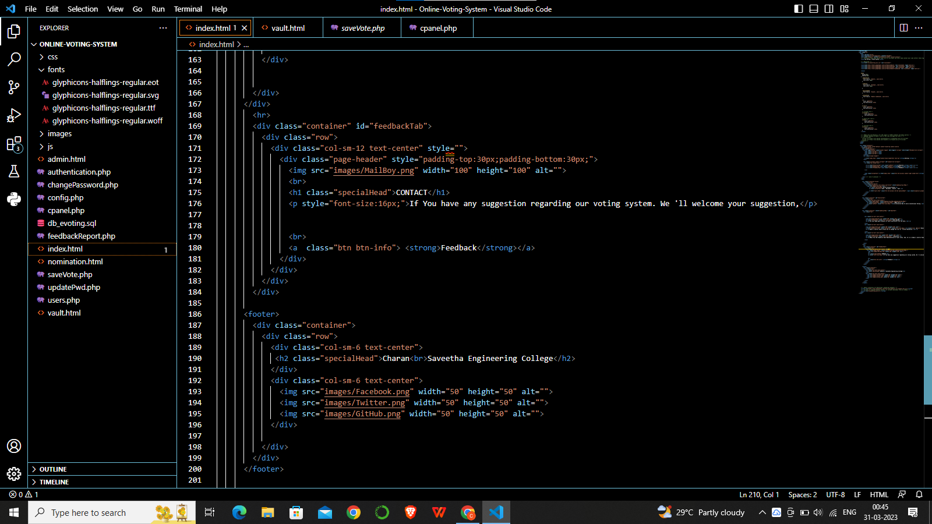

**The above figure shows the implementation and build up of code in Visual Studio IDE.**

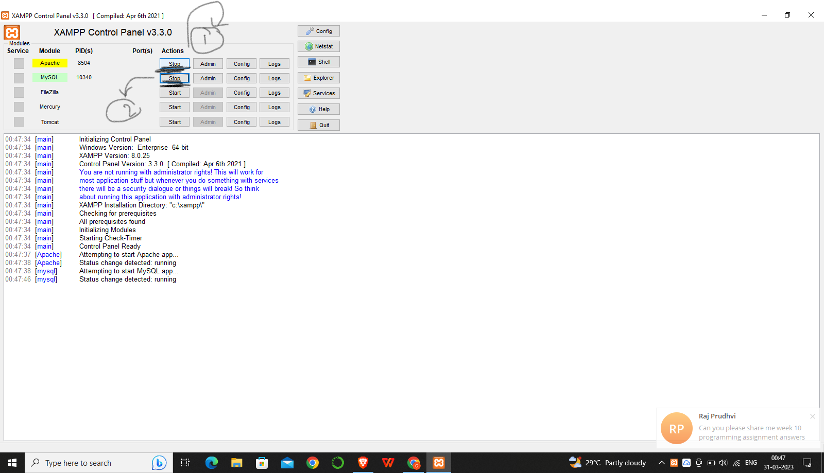

This figure shows the startup of Web Servers And diagnosed to build and run over it.

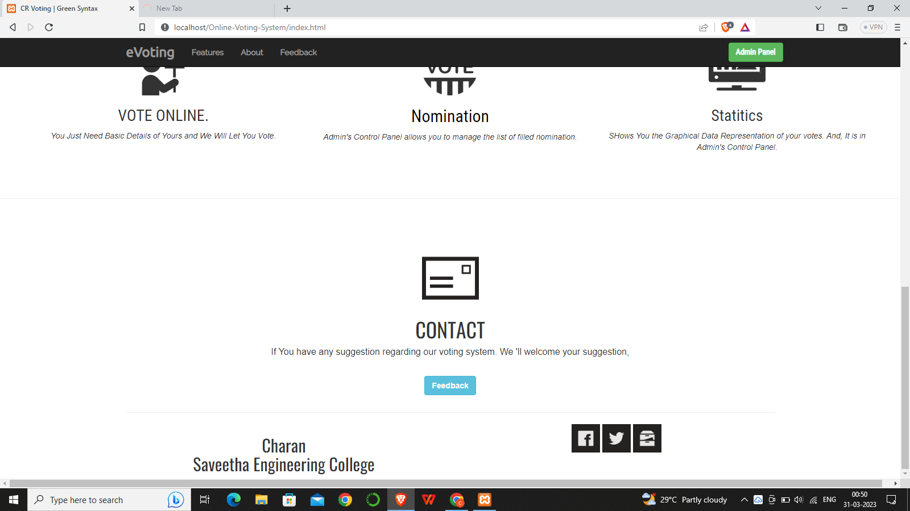

This figure shows the front page of the casting vote..

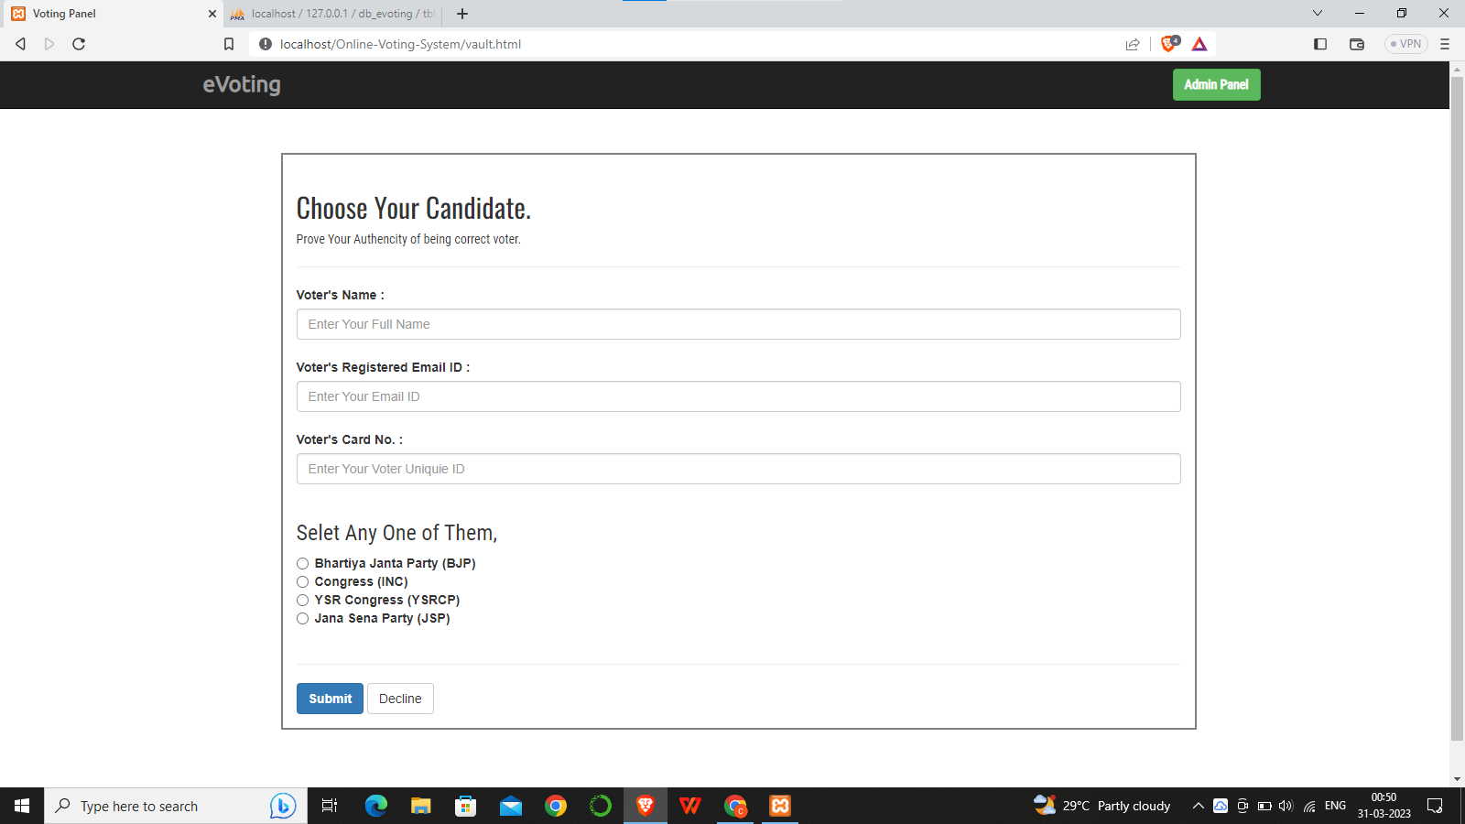

This shows enter the details of candidates and allows users to enter the details and to cast their vote.

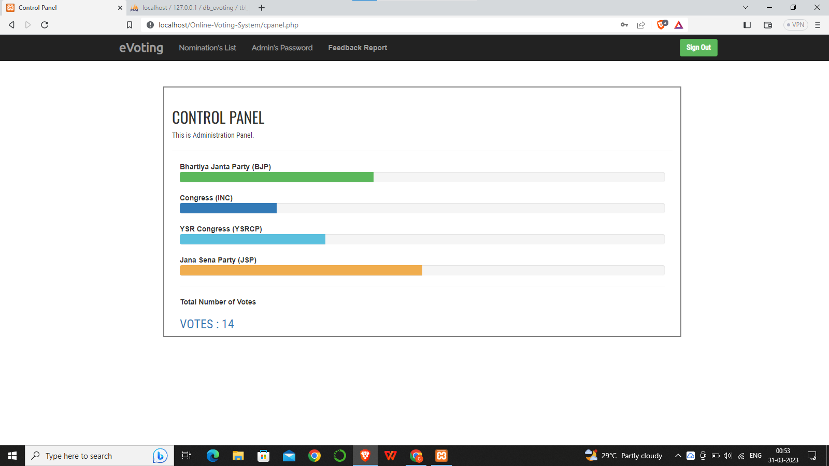

This was the final approach of the proposed system.

**CHAPTER 6**

**CONCLUSION**

Thus, We conclude our Proposed work that an XAMPP Control Panel Allows the Web Server to allow the user to cast on the vote through a browser just by entering the user details of the work that makes the user to be well used and then user can select the desired participant leader to enter the vote. So, it makes the user to poll elections by simply staying home and the proposed system helps the voting securely casted for better election results.

**FUTURE SCOPE**

**Artificial intelligence**: ai can be used to identify anomalies in voting patterns and detect fraudulent activities.

**Increased accessibility:** online voting can help increase accessibility for voters with disabilities or those living in remote areas.

**Integration with existing systems:** online voting systems can be integrated with existing election management systems to provide a seamless and efficient election process.

**REFERENCES**

1. Bell, S.,Benaloh, J.,Byrne, M.D., DE Beauvoir, Eakin. B, Kortum, P.,Mcburnett,N.,Pereira, O.,Stark, P.B., Wallach, D.S.,Fisher, G.,Montoya, J.,Parker.M. andWinn, M. (2013).
2. “Star-vote: Ase-cure, transparent, auditable, and reliable voting system.”, in 2013 Electronic Voting Technology Workshop/Workshop on Trustworthy Elections (EVT/WOTE13). Washington, D.C.: USENIXAssociation,2013.
3. Dalia., Ben.R., PeterY.A, and Feng. (2012). “A fair and robust voting system. ” Bybroadcast, 5th International Conference on E-voting, 2012.
4. Adida,B. ; ‘Helios (2008). “Web-based open audit voting.” in Proceedings of the 17th Conference on Security Symposium, ser.SS’08. Berkeley, CA, USA: USENIX Association, 2008, pp.335348.
5. Chaum.D., Essex. A, Carback.R. , Clark. J., Popoveniuc, S.Sherman and Vora.(2008). “Scantegrity: End-to-end voter – variable optical – scan voting. ”, IEEE Security Privacy, vol.6, no.3, pp.40-46, May2008.
6. Chaum.D., Ryan. Y.A. and Schneider,P.Y.A.(2005). “A practical voter -verifiable election scheme.”, in Proceedings of the 10th European Conference on Research in Computer Security, ser.ES-ORICS’05. Berlin, Heidelberg: Springer-Verlag,2005, pp.118-139.​
7. Chaum,D.(1981).“Untraceable electronic Mail, re-turn addresses, and digital pseudonym.”, Commun.ACM,vol.24,no.2, pp.84-90, Feb.

.

1. "Internet Voting: The Case for Caution" by Barbara Simons and Douglas W. Jones (2013): This paper examines the risks and challenges associated with online voting and argues for caution when implementing such a system.
2. "The Future of Voting: End-to-End Verifiable Internet Voting Systems" by Josh Benaloh, Eric Lazarus, and Rivest Ronald L. (2014): This paper proposes a new online voting system that uses cryptography to ensure the integrity of the voting process.
3. "Online Voting: Rewards and Risks" by the National Conference of State Legislatures (2017): This report provides an overview of the current state of online voting in the United States, including the benefits and drawbacks of implementing such a system.
4. "Election Cybersecurity: Voting Machines and Beyond" by the Brennan Center for Justice (2019): This report examines the vulnerabilities of online voting systems and recommends ways to improve election cybersecurity.
5. "Digital Voting: A Review of Online Voting in Estonia" by R. Merilampi, K. Markkanen, and J. Markkula (2020): This study evaluates the effectiveness of Estonia's online voting system and discusses the lessons learned from its implementation.

**LIST OF PUBLICATIONS**

P.Vinayagam, P. Charan Kumar, P. Venkata Teja, P. Maruthi “Detecting And Preventing Of DOS Attacks in an IOT Based Wireless Sensor Networks”, 2023 in 2023 IEEE Third International Conference on Advances in Electrical, Computing, Communications and Sustainable Technologies (ICAECT 2023).